INSERTION IN AN ARRAY

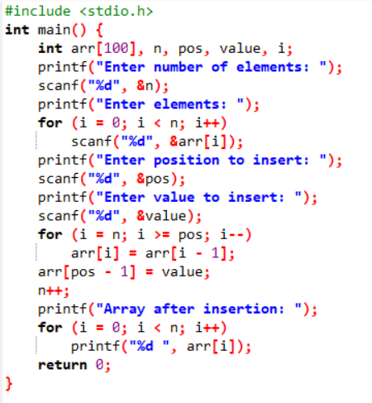

OUTPUT:

